

School of Science and Technology

Student Name: Kalavakollu Naganjaneyulu(N0742702)

MODULE CODE : ITEC40091

MODULE TITLE : Embedded Systems

MODULE LEADER : Pedro Machado

TUTOR(S) : Pedro Machado

- INTRODUCTION: the traffic light signals are reducing the number of accidents. The installation of a traffic signal in san Diego in December 1940. The peoples are travelled to different places in city becoming a difficult for the travellers in traffic.

A traffic light, traffic signal, or stop light is a signal device positioned at a road intersection, pedestrian crossing, or other location in order to indicate when it is safe to drive, ride, or walk using a universal colour code.

the traffic lights for vehicles commonly have three main lights, a red light that means stop, a green light that mean go and yellow that means ready to stop.

RED: The red colour indicated danger.
GREEN: green means to move forward.
YELLOW: yellow means once used to stop.

The traffic jams are very high with in city. the peoples are difficult to cross the city and the one of the main cause of this problem is accident.

The traffic lights have been made where the accident in highly. Now a days is microcontrollers control the most thing around us.

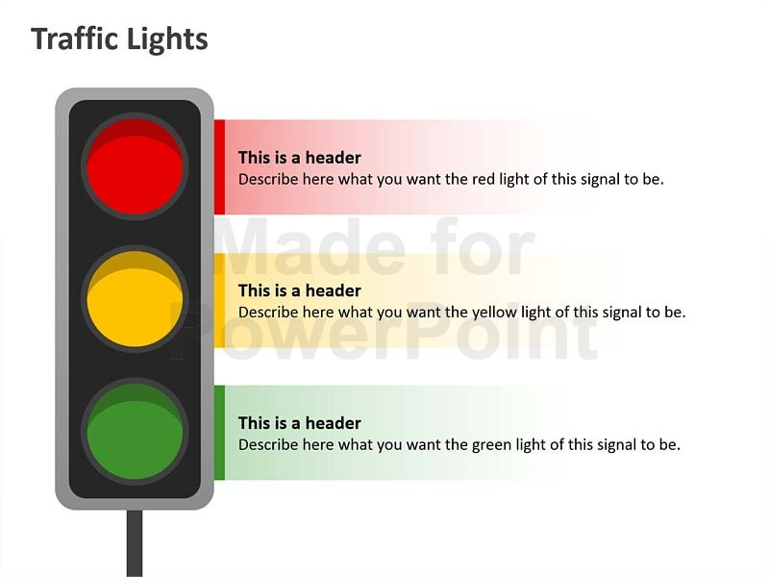

- Relevant background information: the worlds first traffic light was manually operated installed in London in December 1868.In traffic signals are red and green signals. Red means stop and Green means caution. In knights adaptation , we are using only two signals red and green would be signal “stop” and “go” during the day .It was a success and knight predicted more installed.

we are using three modes of operations they are Regular Mode, Pedestrian Mode, and final one is Night Mode.

- Regular Mode: In this regular mode we are using three traffic light signals (red , yellow , green) .these should be connected in parallel and resistors also connected because of we supply high voltage than will damage so resistor stops the voltage and some amount of current passes through the resistor and blink the Red Led lights for 2 seconds , At the same time we are using Yellow Led light for 1 second final one is Green for 2 seconds connected some jumper wires on Arduino to breadboard .And then the again yellow Led for 1 second . The cycle should be repeat until changes the mode.

- Pedestrian Mode: In this Mode we are using one ultrasonic range finder that is SRF05.when we are one object put the range finder then it is move forward and backward of the range finder Until an object is detected less than 10cm from traffic light controls .When we connected the buzzer it should like beep sound occurs and must be the Yellow light blink ON/OFF continuously 10 times .When the Mode is changes to Regular mode then it should be stoop the buzzer.

- Night Mode: In this Mode we are using Light Dependent Resistor(LDR). The main function of LDR is how much the light falls in one mode to another mode Using the LDR the traffic light controls should operate in the Regular mode the amount of high the threshold ,when the drops to below the threshold energy then the Red led should ON, when the traffic light controls changes to Mode.

- Methodology: Long lines of vehicles, high range of stop-time in intermediate and cultural emissions are only some of the problems that traffic light control is looking forward to avoiding the minimum traffic lights control.

Manuscript received march 23 2015; J. Laria , J. A. castan ,S. Ibarra, revised 08,2015, M.G. Trevino ,GUZMAN are numbers of the computer technology group at the engineering school at the autonomous university of Mexico.

For example cars in traffic can experience long travel distance due to inefficient pre programmed control of the traffic lights. The optional control of traffic lights.

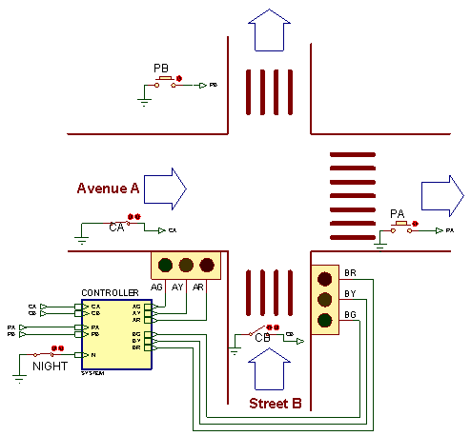

4.Final Design Solution: We are using three LEDS, three Resistors, one LDR, one Buzzer, jumper wires, Arduino and breadboard, one Range Finder are using in traffic light control.

Requirements:
Resistors: three 330k ohms.
LEDs : Red, Yellow, Green.
Arduino : version 18.1.2.
Breadboard and jumped wires.
SRF05
LDR
Buzzer
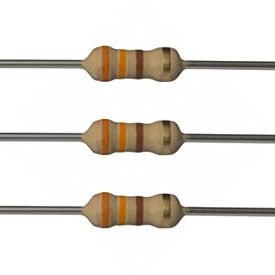
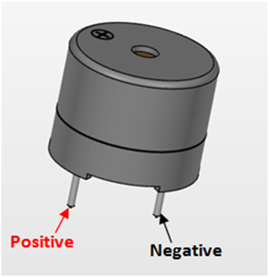

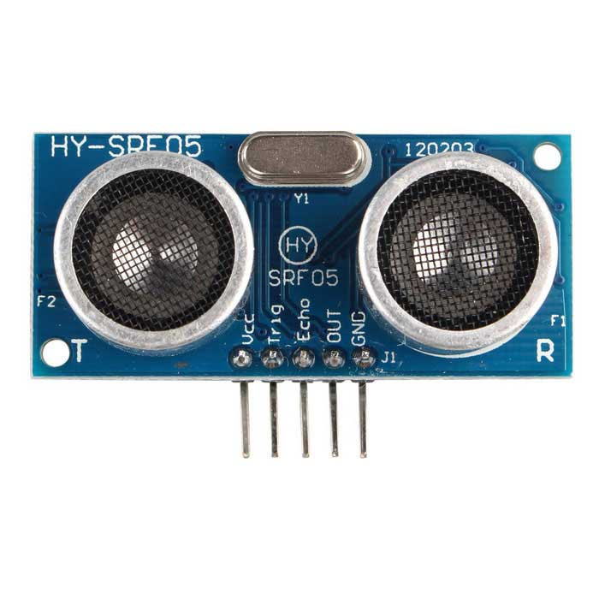

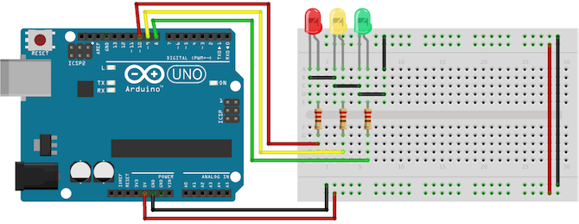
5.Conclusion: finally , we are using three traffic light signals are proper working and good result. the traffic congestion of the road is one of the main problem is control the traffic to reduce the major and minor accidents. In this sense, the paper introduces a novel methodology to manage traditional traffic control using intelligent agents.

In this paper, the mainly thing has been basically on vehicular traffic and on the mobility and environmental cultural using intelligent agents to control the traffic of the lights. In future the traffic lights are very main thing is peoples are rude ride the bikes and cars any motor field are safe drive and hopefully this should be success to control traffic.

